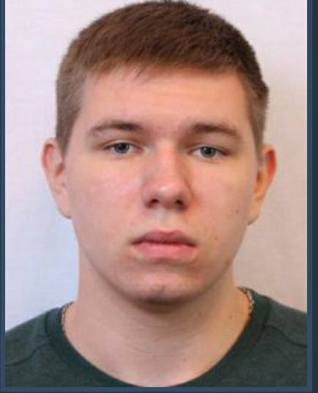**Mykyta Poberezhnik**

**+(380)50-65-44-614**  
[**thelesnikgood@gmail.com**](mailto:thelesnikgood@gmail.com)  
**No Relocate**  
**Remote Work  
Kharkiv, Ukraine**

**Junior Software Developer**